**National war Memorial**

**(Self-Initiated)**

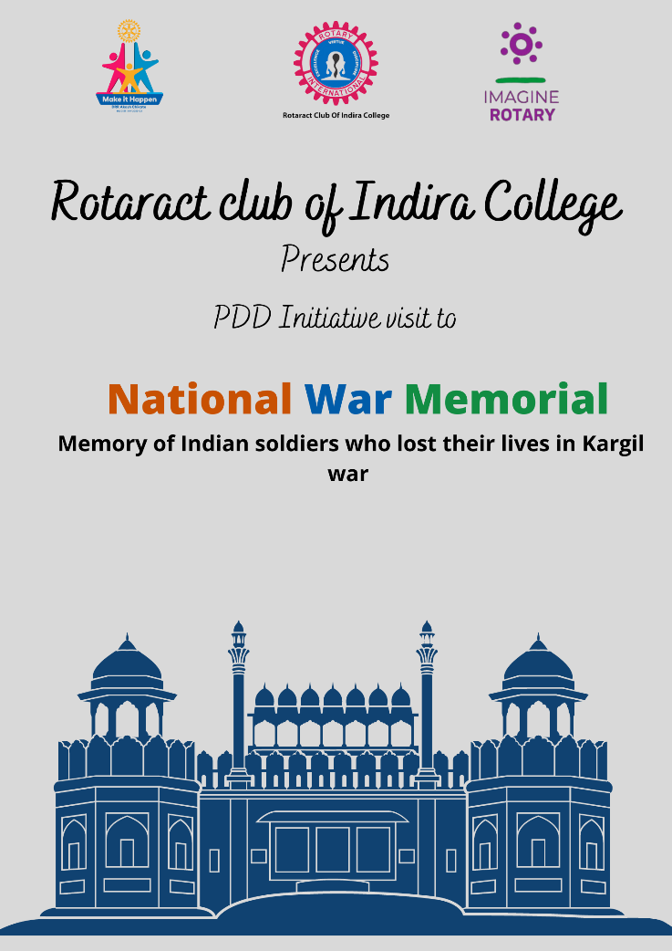

**Event in brief:**

* **Date: 06/09/2022**
* **Time: 10 am onwards**
* **Venue :National War Memorial ghorpodi pune**
* **Agenda:**

The Material which was used in war and guns, rifle, missile was kept there and Maratha empire, many more empire was their.

* **Pictures:**

